Din Tai Fung’s competitors in Seattle

Tiange Tang

## Background and Business Problem

Din Tai Fung is one of the most famous dumpling places around the world. Nowadays, Din Tai Fung has branches in Japan, the United States, South Korea, Singapore, China, Hong Kong, Indonesia, Malaysia, Australia and Thailand.

In Seattle, for example, there are already 4 branches of Din Tai Fung. Customers are wondering about the dumpling restaurants that might be as good as or even better than Din Tai Fung. Who are Din Tai Fung’s competitors in Seattle? Can we cluster them into different tiers?

To answer these questions, we get Din Tai Fungs’ and their nearest dumpling restaurants’ branch numbers and ratings within 30km of distance from Foursquare API, and their specialty (Pork/Chicken Dumpling)’s price from menus posted by customers on Google. We use all these data to perform the K-means Clustering and identify the key competitors.

1. Data acquisition and cleaning

First, we want to get each Din Tai Fung branch’s rating in Seattle from Foursquare API and calculate the average rating of Din Tai Fung in Seattle. It is 8.825.

To get the numbers of competitors around each Din Tai Fung branch, we set the distance to be 30km. We drop off the duplicate values and get the rating for each competitor. There are some dumpling restaurants that do not have any ratings, we’d assume that these are not that popular and are not worth considered to be Din Tai Fung’s major competitors. We also count the number of branches for some chain dumpling restaurants.

We also want to consider the general pricing for each dumpling restaurant. We’d assume that each dumpling restaurant’s specialty is pork/chicken dumplings (this is also the major reason why people go to Din Tai Fung), and its price can represent the general pricing for the restaurant. We get the prices from the menus that customers uploaded on Google. We set some price to zero of some nearby dumpling restaurants because they do not have any related dumpling dishes like Din Tai Fung’s even though they are categorized as Dumpling Restaurant on Foursquare API.

We merge the all the information, and we get this table.

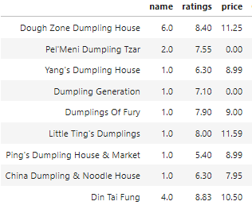

where Name stands for the number of branches, Ratings stands for the average rating of all the branches for a restaurant, and Price is the specialty dish’s price in a restaurant.